SPECIAL EDUCATIONAL NEEDS OR DISABILITY (SEND) POLICY

This policy should be read in conjunction with the following policies and documents:

SEND Code of Practice (2015)
Section 69 of the Children and Families Act 2014
Accessibility Plan
Admissions Arrangement
Behaviour Policy
Child Protection Policy & Keeping Children Safe in Education
Equality Information and Objectives Statement
Home-School Agreement
Medical Conditions Policy
Personal and Intimate Care Policy
Joydens Wood Infant School Curriculum 2022-2023
Teaching and Learning Policy

Written by: Emma Blake & Amy Vinton

Reviewed by: Amy Vinton
Date of Review: July 2022

Next Review date: July 2023

Intent
Statement of Intent
We are committed to inclusion, working together to make our school a place where every child feels happy, safe and is fully included in all aspects of school life. We implement Quality First Teaching (Appendix 1) across the curriculum to enable every child to achieve to their best, become confident individuals living fulfilling lives, whilst removing barriers to their learning. We promote provision that drives pupil’s wellbeing, attainment and progress whilst identifying any additional needs as they arise and ensuring that the provision for pupils with Special Educational Needs or Disability (SEND) are not treated less favourably than others. We believe that early intervention is key, therefore we strive to identify and provide effective early support to children who may be at risk of poor outcomes.
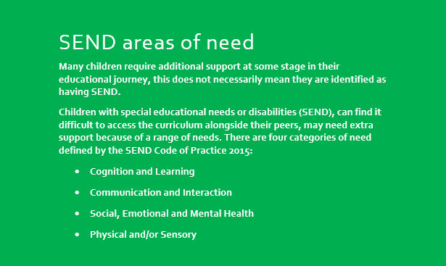
Due to the age of our children, we believe it is most important to initially support their prime areas of learning: personal, social and emotional development (PSED), communication and language (CL) and physical development (PD). These areas enable children to understand and manage their emotions, set and achieve positive goals, establish and maintain positive relationships and develop their gross and fine motor skills to access the provision effectively.
If a child is identified as requiring additional support, assessed by using our specific criteria which is based on the Communication & Interaction scales and the Emotional & Behavioural scales, it may be appropriate for them to access The Hive.
The Hive is our additional support provision targeting social and emotional well-being needs through small group interventions such as: Emotional Literacy, Social Skills, LEGO Therapy and Therapeutic Play. The Hive follows a Personal Development Curriculum based on the individual needs of the children who have met the criteria. These follow a progression of skills over a 6-week period (Appendix 2) and children will receive a “Hive Passport” (Appendix 3) earning a stamp after each visit. Once a child has attended for a maximum of 6-weeks, they will graduate from The Hive and the impact will be monitored for a further 6 weeks.
Play underpins the development of our children until fundamental skills and knowledge have been embedded. The Hive provision is set up to reflect this, with continuous provision enhancements within the environment.
SEND Code of Practice 2015
High quality teaching that is differentiated and personalised will meet the individual needs of the majority of children and young people. Some children and young people need educational provision that is additional to or different from this. Schools must use their best endeavours to ensure that such provision is made for those who need it. Special educational provision is underpinned by high quality teaching and is compromised by anything less. Early years providers and schools should know precisely where children and young people with SEN are in their learning and development. They should:
• ensure decisions are informed by the insights of parents and children
• have high ambitions and set stretching targets for them
• track their progress towards these goals
• keep under review the additional or different provision that is made for them
• promote positive outcomes in the wider areas of personal and social development, and
• ensure that the approaches used are based on the best possible evidence and are having the required impact on progress.

Implementation: Teaching and Learning

Planning
Teachers should refer to the Mainstream Core Standards (KS1) and the Best Practice Guidance (EYFS) to inform and steer practice. These are available at: The Mainstream Core Standards

Use Quality First Teaching (QFT) referring to the Mainstream Core Standards or Best Practice Guidance dimensions
Provision is implemented at a Universal Level.

SEN
support

Additional needs are identified and provision is implemented at a Targeted Level
Interventions are recorded on the Whole School Provision Map and progress is tracked on Intervention Records (Appendix 2) using SMART targets.

Planning
progress

Provision is implemented at a Personalised Level following a Graduated Response
(Plan, Do, Assess, Review)
A Personalised Plan is implemented
Needs may be discussed at Local Inclusion Forum Team (LIFT)
Higher Needs Funding (HNF) may be applied for
Statutory Assessment (EHCP) may be explored.

High
Needs
Teachers should follow the subsequent steps to ensure the most appropriate intervention is in place at a universal, targeted and personalised level so that children can make progress both in their well-being and attainment.

Five Step Plan for SEN Concerns
Teachers should follow the Five Step Plan for SEN Concerns (Appendix 4) to guide them in addressing specific areas of need, implementing appropriate support and intervention and communicating all steps of intervention and support with parents at regular intervals.

QFT → Interventions → SIFT → SEN Clinic Review → SEN Register & External Support

SIFT
Once QFT and Interventions via the Whole School Provision Map have been implemented and further additional support and guidance is still required, teachers may refer a child to the School Inclusion Forum Team (SIFT) by completing a SIFT Referral Form (Appendix 5). This is submitted to the SENCO who will lead a SIFT Meeting at the next available Staff Meeting. A SIFT Meeting consists of all teaching staff, SENCO and Family Engagement Leader (FEL) discussing the needs of the child and suggesting recommendations for strategies and support. Actions are agreed on the SIFT Recommendations Form (Appendix 6) and a date for review at SEN Clinic is set (between 6-12 weeks after the SIFT Meeting).

SEN Clinic
Any staff member can discuss the progress, attainment and/or support for a child/ren they work with by booking into the SEN Clinic. This takes place weekly, run by the SENCO. Appointments can be booked via the Google Calendar by entering “NAME: SEN CLINIC” at the desired time.

Teaching - “All teachers are teachers of SEN children” (Code of Practice, 2015)
Teachers are expected to make reasonable adjustments to their teaching practice and, where necessary, bespoke educational opportunities are planned for to ensure that all children can be included in the learning. Effective learning will be assessed in a range of ways, for example but not exhaustive of: written record, scribed or transcribed by an adult, video or voice recording, photographs. Teachers are expected to ensure the children have equal opportunities and access to the Joydens Wood Infant School Curriculum, ensuring that the children have a progressive educational and personal journey that enables them to:
- Develop strong fluency and confidence in the foundations in Literacy and Mathematics.
- Lead their own learning through child-led and enquiry-based opportunities.
- Think critically and make links through a cross curricular approach which is underpinned by key texts.
Our Joydens Wood Infant School Curriculum is designed to be ambitious and diverse, enabling all children regardless of their background and barriers to have the right opportunities to flourish in their learning. We provide a ‘Nurture’ approach for our children who require the curriculum to be delivered in a more holistic and pastoral way.

Children should always have access to a range of resources in line with the expectations of Quality First Teaching (Appendix 1). Where additional, personalised resources are required, these should be sought out in a timely manner, in discussion with the SENCO and parents if appropriate. All children should be exposed to rich, subject-specific vocabulary alongside their peers however, if this is not accessible for an individual then personalised, targeted vocabulary should be provided; planned for by the teacher.

Resources
- SEN resources are stored in the cupboards in The Hive.
- Individual classes may store child-specific resources throughout the year when they are used on a regular basis – these must go up to the next class with the child or returned to the resource cupboard when no longer required.
- All staff members may access the resource cupboard with the expectation that resources are returned once they are no longer required.
- Teachers are expected to create individualised resources for specific children where necessary e.g. now/next boards, visual timetables, behaviour charts.
- Any additional resources required that staff have difficulty making or sourcing must be brought to the attention of the SENCO and Headteacher for approval.
- Teachers should use Quality First Teaching classroom display guidance and “communication-friendly” classroom display guidance where possible (Appendix 7).

Assessment
All children’s academic attainment and progress is assessed in line with the school’s normal practice of inputting subject specific data into SIMS. Children receiving Targeted Provision (outlined on the Whole School Provision Map) will have their SMART target reviewed after 6 weeks, recorded on the Intervention Record Sheet (Appendix 8). If the SMART target has been met, targeted intervention would cease for at least 6 weeks to allow the impact of the intervention to be monitored. If the SMART target has not been met, the child’s provision would be reviewed by the class teacher (in discussion with the SENCO and parents if appropriate) to determine the next course of action to support the child’s needs.

Children with a Personalised Plan or an Education, Health and Care Plan (EHCP) will have their SMART targets reviewed at least 3 times per year where progress and next steps are shared and agreed with parents. Children with an EHCP will have their overarching outcomes reviewed annually at their Annual Review where parents and any outside agency professionals are invited.

SENCO, Teachers or Support Staff can use a range of assessment tools and checklists to determine specific needs of children. These may include:

- Neurodiversity Checklist
- Emotional & Behavioural Scales
- Communication & Interaction Scales
- Sensory Checklist
- Speech and Language: ICAN Chart
- School Stress Survey
- SDQ Questionnaire
- Parent/Teacher/Child Voice Questionnaire
- The Leuven Scales

Children accessing The Hive will be assessed using The Hive Criteria at the beginning and at the end of a 6-week intervention.

Vulnerable Learners
All pupils should be constantly supported/challenged as necessary. Careful consideration in the ‘barriers to learning’ will enable teachers to form a picture as to how a child’s life experiences/opportunities hinder their development in each area of the curriculum.
- SEND and EAL pupils: resources and support should be planned for, as outlined in this policy, to enable all children to have access to the learning. Suitable aids that are relevant to the child should be reviewed for their suitability and impact. Where necessary a risk assessment should be undertaken.
- Disadvantaged pupils: children have external circumstances that affect their ability to access certain aspects of school. This could affect their punctuality, attendance or ability to access the curriculum. The school is expected to identify these contributing factors rapidly to ensure every child has the same opportunities to access their learning. This may involve discussing the child’s home life with the DSL or FEL.
- In-year admissions and Persistent Absentees: children who have not attended our school previously or have poor attendance are at risk of not being able to access the learning. They may have significant gaps in their skills and knowledge that prevent them from being able to access specific skills. All children that are new/returned to school following a period of absence should be carefully monitored to ensure support is implemented without delay. In some cases, it may be necessary to undertake a risk assessment.

Extra-Curricular Activities
All children have the opportunity to sign up to extra-curricular clubs linked to our school’s teaching and learning. The same expectations in terms of equality, accessibility and reasonable adjustments are required to ensure all children have the opportunity to take part. All children are included in extra-curricular trips and reasonable adjustments and additional support is implemented as required.

Parent Partnership
Liaising with parents regarding the Special Educational Need or Disability of their child(ren) is imperative. Where possible, before a child starts at Joydens Wood Infant School, the SENCO will liaise with the parents and the child’s nursery/pre-school or previous school to gain an insight into the needs of the child(ren) and the level of additional support required. Information gathering and sharing of information is vital in ensuring an effective transition into our school.

Throughout the child’s journey at school, parents will be regularly informed of their child’s attainment and progress twice yearly at parent consultation meetings. If a child has a Personalised or Provision Plan, these plans are reviewed at least 3x per year in consultation meetings with parents. Staff must use the Five Step Process to SEN Concerns to inform them of specific intervals when parents should be informed and the nature of the information shared. Any additional meetings or conversations will be arranged as and when required. All communication and information shared must be inputted on CPOMs.
Impact
The SENCO is responsible for:
- Developing the school’s SEND Policy.
- Coordinating interventions and support in liaison with the Class Teacher.
- Ensuring parental involvement in supporting children’s provision, progress and attainment, in liaison with the Class Teacher.
- Liaising with outside agencies and professionals who may be involved.
- Updating the school’s SEND register.
- Updating the school’s Provision Map.
- Taking children’s cases to the Local Inclusion Forum Team (LIFT) to seek further specialist support and advice where required.
- Completing and submitting outside agency referrals in liaison with the Class Teacher.
- Working collaboratively with Class Teachers and SLT to ensure that SEND Provision is robust, effective and transparent.
- Ensuring SEND children’s records are kept up to date.
- Reviewing SEND Provision and interventions annually.
- Monitoring provision and interventions throughout the year in a variety of ways e.g. include environment and learning walks (recorded on an impact form) and review of intervention records (Appendix 8).

Continued Professional Development
- SEND updates and training will be provided termly by the SENCO and the training provided will be relevant to the current needs of the school.
- All staff have received basic awareness training of speech and language difficulties, Epilepsy training and safeguarding/child protection training, a number of staff are also trained in ASD/ADHD awareness.
- In addition, some staff members have received the following enhanced and specialist training:
- Sensory Circuits
- Language for Learning
- Maths Mastery Interventions
- Better Reading Partnership
- Speech and Language Link
- ASD support
- Therapeutic play
- Lego therapy
- BEAM

Additional support

The local authority’s local offer is published on:
https://www.kent.gov.uk/education-and-children/special-educational-needs

Parents without internet access should make an appointment with the SENCO for support to gain the information they require.

Key Contacts

SENCO
Miss Emma Barnett senco@joydens.org

Acting SENCO
Miss Amy Vinton senco@joydens.org

Family Engagement Leader (FEL)
Mrs Carly Adams c.adams@joydens.org

Appendix 1

Strategies for all learners – Quality First Teaching checklist (including but not exhaustive)

Well organised classroom with labels: words, symbols and/or real life photographs

Plan by deciding what everyone can learn and then add or remove scaffold

Clear lesson structure using “chunking” as a teaching method and using a range of learning styles e.g. listening, seeing, doing

Implement a range of Active Learner strategies e.g. talk partners, movement breaks, random questioning (named lolly sticks)

Understanding is demonstrated in a variety of ways e.g. explain to your partner, explain to the class, give an example

Use of whole class timer

Use of whole class now/next and break down instructions

Visual timetable

Range of groupings within the class e.g. random pairing, mixed ability

Five positive comments to one negative

Praise is specific and often

Memory supported by explicit demonstrating and modelling of memory techniques

Classroom assistants well planned for and used to maximise learning

Key vocabulary is evident and used consistently

Pupil expectations are high and clear

Behaviour management strategies are clear and used consistently

Resources and stimulus are used regularly and consistently e.g. wow moments to hook learning, number lines, word mats, maths boxes, phonics prompts

Appendix 2

Emotional Literacy – Progression of Skills

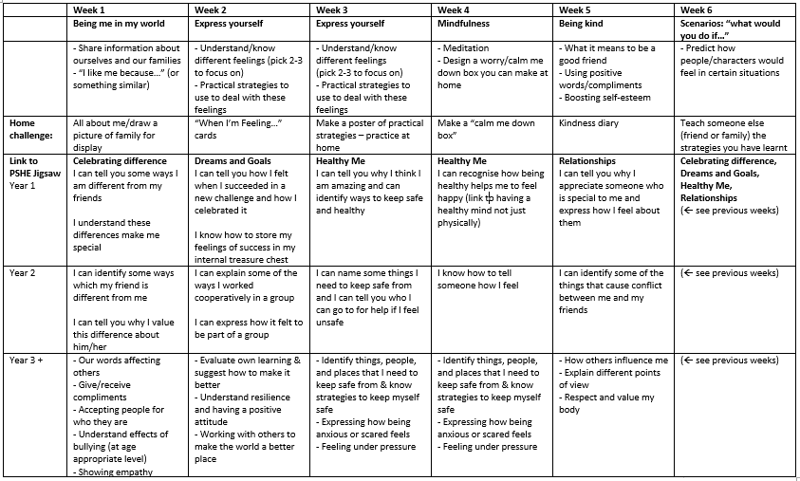

Lego Therapy – Progression of Skills

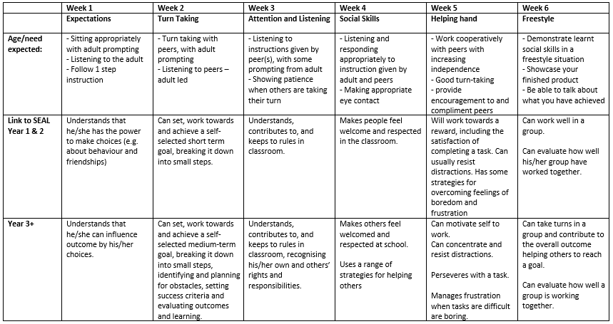

Appendix 3

My Hive Passport

Bee’s Name: __________________________

Collect a stamp on your flower for every time you visit The Hive

Appendix 4

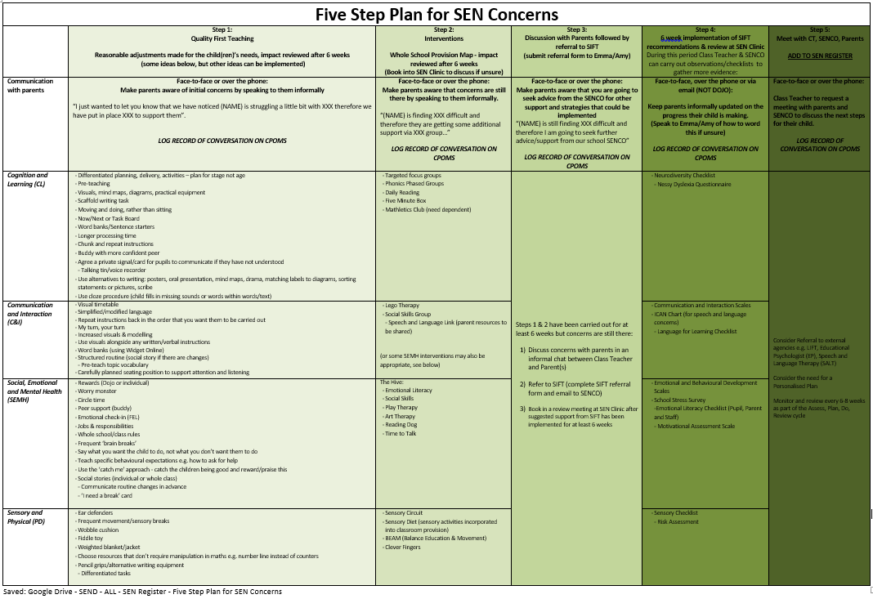

Appendix 5
SIFT – School Inclusion Forum Team
Pupil Name & Class: | Completed by: | Date:
Identified area of need (highlight/circle all applicable) | Cognition & Learning (CL)  Social, Emotional, Mental Health (SEMH)  Communication & Interaction (CI)  Physical/Sensory (PD)  Speech, Language & Communication Needs (SLCN)  Unsure
Mainstream Core Standards (MCS) | Have you referred to the Mainstream Core Standard?  Yes/No  If no, please refer to the MCS for any additional support you can implement either at Universal (QFT) or Targeted level (Whole School Provision Map)
Outline of Concerns:
What other strategies/interventions have you implemented so far? (Include frequency and impact where possible)
What is the impact on attainment/progress?

Have parents been informed? | Yes / No  If Yes – please include a brief outline of their response  If No – please outline why
What further help would you like to receive?

Appendix 6

SIFT – School Inclusion Forum Team - Recommendations
Pupil Name & Class: |  | Completed by: | Date:
Concerns raised:

Key discussion point (what does the child/teacher find difficult)

Recommendations/agreed action at SIFT:
- Class Teacher actions
- SLT/SENCO actions

Review date:
Book into SEN Clinic to discuss/review actions.

Appendix 7

Communication-friendly classroom

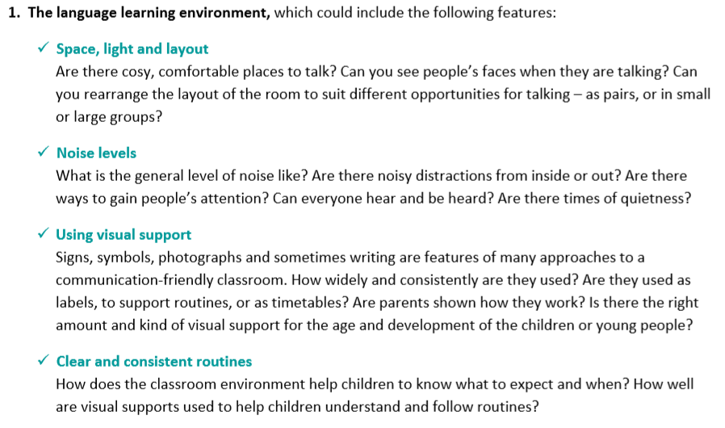

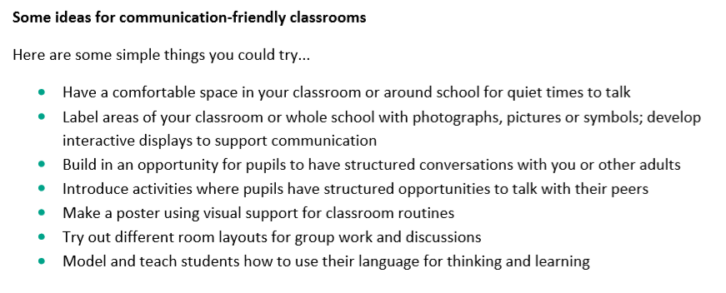

Appendix 8

Intervention Record
Intervention: ……………………………………. Lead by: ……………………………….
Start date: …… End date: ……
Reason for the children in this group:
Aim(s) of intervention:
SMART Target (something that is measurable e.g. for Clever Fingers “By XXX I will be able to thread the lace on the shoe on 3 consecutive occasions” this can be the same target for multiple children if appropriate)
Name | Week 1 (no./tally of sessions attended that week) | Week 2  (no./tally of sessions attended that week) | Week 3 | Week 4 | Week 5 | Week 6 | Week 7 | Additional week | Outcomes (results of child attending intervention for 6-8 weeks – linked back to original aim).

Observation of children in their classroom by intervention leader (to be done once per round of interventions e.g. every 6 weeks):
Name: | Date: | What was seen (link to SMART target where possible) – think about the skills you are teaching them in your intervention, can you see any example of them being transferred into the classroom, make brief notes e.g. able to sit calmly on the carpet for 3 minutes during teacher led activity (could be linked to sensory circuit), able to wait their turn with their hand up (could be linked to LEGO therapy)

